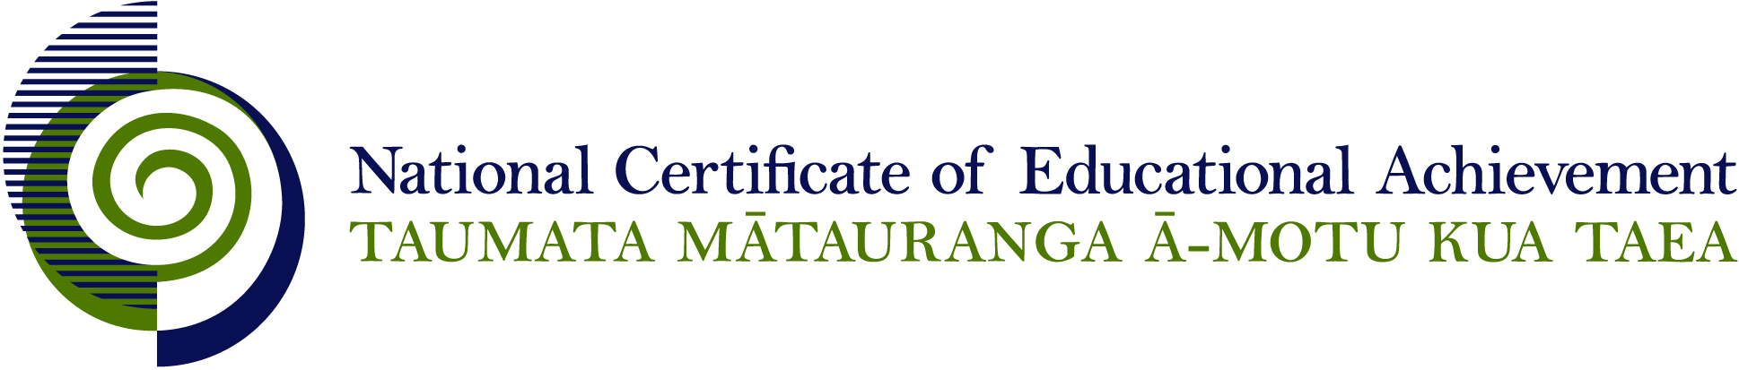

NCEA Level 3 Earth and Space Science

Conditions of Assessment

General Information

Subject Reference | Science
Domain | Earth and Space Science
Level | 3

Conditions of Assessment

These Conditions provide guidelines for assessment against internally assessed Achievement Standards. Guidance is provided on:
- specific requirements for all assessments against this Standard
- appropriate ways of, and conditions for, gathering evidence
- ensuring that evidence is authentic.

Assessors must be familiar with guidance on assessment practice in learning centres, including enforcing timeframes and deadlines. The NZQA website offers resources that would be useful to read in conjunction with these Conditions of Assessment.

The learning centre’s Assessment Policy and Conditions of Assessment must be consistent with NZQA’s Assessment Rules for Schools with Consent to Assess. This link includes guidance for managing internal moderation and the collection of evidence.

Gathering Evidence

Internal assessment provides considerable flexibility in the collection of evidence. Evidence can be collected in different ways to suit a range of teaching and learning styles, and a range of contexts of teaching and learning. Care needs to be taken to allow students opportunities to present their best evidence against the Standard(s) that are free from unnecessary constraints.

It is recommended that the design of assessment reflects and reinforces the ways students have been learning. Collection of evidence for the internally assessed Standards could include, but is not restricted to, an extended task, an investigation, digital evidence (such as recorded interviews, blogs, photographs, or film), or a portfolio of evidence.

Effective assessment should suit the nature of the learning being assessed, provide opportunities to meet the diverse needs of all students, and be valid and fair.

Ensuring Authenticity of Evidence

Authenticity of student evidence needs to be assured regardless of the method of collecting evidence. This must be in line with the learning centre’s policy and NZQA’s Assessment Rules for Schools with Consent to Assess.

Ensure that the student’s evidence is individually identifiable and represents the student’s own work. The evidence must be an accurate reflection of what the student independently knows and can do, according to the Standard being assessed. This includes evidence submitted as part of a group assessment, evidence produced outside of class time or without assessor supervision, and evidence produced with any use of generative artificial intelligence tools (GenAI). GenAI use should be carefully considered in the context of the Standard being assessed and its Conditions of Assessment, discussed with students before the assessment, and its use must be acknowledged. For example, an investigation carried out over several sessions could include:
- teacher guidance on the nature and extent of acceptable GenAI use, if any
- assessor observations and conversations
- meeting with the student at set milestones or checkpoints
- the student’s record of progress, such as photographic entries or any GenAI prompts used.

Specific Information for Individual Internal Achievement Standards

Achievement Standard Number | 91410 Earth and Space Science 3.1
Title | Carry out an independent practical Earth and Space Science investigation
Number of Credits | 4
Version | 1

The investigation may be carried out in a laboratory or as part of a field trip.

A common context for the investigation in a group of students is permissible. Planning, collecting raw data, processing, interpreting, and evaluating may be undertaken in small groups but the teacher needs to ensure that there is evidence that each student has met all aspects of the standard.

Guidelines for the investigation could include the context, and broad conditions such as the availability of equipment or chemicals.

Safety considerations appropriate to the investigation must be provided.

Discussion with students throughout the investigation in order to clarify ideas and methodology is appropriate.

The teacher determines the time taken for the assessment, in negotiation with the student, as this is dependent on the context being used.

Appropriate technology such as data loggers and computers may be used.

Achievement Standard Number | 91411 Earth and Space Science 3.2
Title | Investigate a socio-scientific issue in an Earth and Space Science context
Number of Credits | 4
Version | 1

Investigate a socio-scientific issue involves research and the collection of primary and/or secondary scientific information and/or data from a variety of sources such as websites, interviews, resource sheets, photos, videos, and reference texts.

A socio-scientific issue is a scientific issue which has impact on individuals and society. There must be a key Earth and Space Science aspect to the issue. For example, mining on the West Coast, mining on conservation land, fracking on the Canterbury plains, oil drilling on the East Coast, seabed dredging, lignite mining in Southland, deep sea mining around the Kermedecs, man and unmanned Space exploration, mining sea beds for iron ore, climate change, ocean acidification, desertification, or farming practices.

The investigation is to be student driven. The student is to select the issue, either from a list provided by the teacher, the student’s own research or a common context.

Planning, collecting information, processing, justifying, and evaluating may be undertaken in small groups but the teacher needs to ensure that there is evidence that each student has met all aspects of the standard.

The role of the teacher is to guide and support the student throughout the investigation. Teacher support gives general information only, e.g. in the form of broad questions, resource suggestions or possible new directions.

Authenticity is a school management responsibility and will be determined by appropriate measures such as teacher observation, and other supporting evidence such as sources of information appropriate to the investigation and student blog posts Evidence of selecting scientific information should be in the form of resources which show evidence of highlighting, listing, sorting, collating, and/or summarising. This can be in electronic or hard copy.

Achievement Standard Number | 91412 Earth and Space Science 3.3
Title | Investigate the evidence related to dating geological event(s)
Number of Credits | 4
Version | 1

Assessment against this standard may be by one of or a combination of a field trip, oral or written report, collection of data through observations/field trip, or poster/infographic

A common context is permissible. Teachers may provide a range of resource material or suggest websites that students select information from. Students may also select their own resource material.

The student must clearly demonstrate understanding of the science relevant to the dating of a geological event by putting relevant concepts and information into their own words. Teachers may also question the student to confirm understanding.

The teacher determines the time taken for the assessment, in negotiation with the student, as this is dependent on the form of assessment being used.

Achievement Standard Number | 91415 Earth and Space Science 3.6
Title | Investigate an aspect of astronomy
Number of Credits | 4
Version | 1

Assessment against this standard may be by one of or a combination of report, collection of data through observations, or poster/infographic.

A common context is permissible. Teachers may provide a range of resource material or suggest websites that students select information from. Students may also select their own resource material.

The student must clearly demonstrate understanding of the science relevant to the astronomical aspect by putting relevant concepts and information into their own words. Teachers may also question the student to confirm understanding.

The teacher determines the time taken for the assessment, in negotiation with the student, as this is dependent on the form of assessment being used.

Appropriate technology and software may be used.

